

Khoa Công Nghệ Thông Tin

Software Requirements Specification (SRS) Document
Course: System Integration Practices`
Project Title: Integrated HR & Payroll Dashboard System for Company X
Case Study 2, 3: System Requirement Analysis & API Design
Version: 1.0
Date: 18/03/2026
Group: Group 5
Semester: 2 – 2025-2026
Instructor: MSc. Nguyen Dang Quang Huy
Team Members:
Name | Student ID
Thong, Le Huu | 29219038101
Rin, Doan Ba | 29219037721
Tai, Su Phat Tai | 29211162809
Minh, Vo Van | 29219261748
Vinh, Nguyen Tran Xuan | 29211138585
Approved by
MSc Huy, Nguyen Dang Quang

Da Nang 03/2026
Project Acronym | HRD
Project Title | Company X – Integrated HR & Payroll Management Dashboard
Start Date | 11 Mar 2026 | End Date | 18 Mar 2026
Lead Institution | International School, Duy Tan University
Role | Name | Email |  | Phone
Project Mentor | Nguyen Dang Quang Huy
 | Le Huu Thong | bass030196@gmail.com |  | 0768463655
 | Su Phat Tai | phattai0935@gmail.com |  | 0766657942
 | Nguyen Tran Xuan Vinh | xuanvinh2005nh@gmail.com |  | 0845015537
 | Vo Van Minh | vanminhvo2005@gmail.com |  | 0707944067
 | Doan Ba Rin | doanbarin@gmail.com |  | 0766721747

DOCUMENT NAME
Document Title | Software Requirements Specification (SRS)
Reporting Period | 29– March - 2026
Author(s) | Le Huu Thong  Vo Van Minh  Su Phat Tai  Doan Ba Rin  Nguyen Tran Xuan Vinh
Role | Developer
Date | 18/03/2026 | File name | 4. Software Requirement Specification_IEEE 830-1998.docx

DOCUMENT APPROVALS
Document Approvals: The following signatures are required for approval of this document.
Mentor | Huy, Nguyen Dang Quang | Signature:
 |  | Date:
 |  | Date:
Team member(s) | Thong, Le Huu | Signature:
 |  | Date:
 | Tai, Su Phat | Signature:
 |  | Date:
 | Rin, Doan Ba
 | Vinh, Nguyen Tran Xuan
 | Minh, Vo Van | Signature:
 |  | Date:

TABLE OF CONTENTS
1. Introduction 8
1.1 Purpose of the Document 8
1.2 Scope of the Document 8
1.3 Definitions, Acronyms, Abbreviations 8
1.4 References 9
1.5 Overview 9
2. Overall Description 10
2.1 Purpose of the System 10
2.2 Scope of the System 10
3. General Requirements and User Characteristics 11
3.1 Product Perspective 11
3.2 System Context Diagram 11
3.2 Product Functions 11
3.3 User Characteristics 12
3.4 Constraints 12
3.5 Assumptions and Dependencies 12
4. Specific Requirements 12
4.1 Functional Requirements 12
4.2 Non-functional Requirements 14
4.3 External Interface Requirements 15
5. System Models 16
5.1 Business Function Diagram (BFD) 16
5.2 List of Use Case 16
5.3 Use Case Diagram Overview 17
5.4 Use Case Specification: 18
5.5 Activity Diagram 49
5.6 Sequence Diagram 57
6. Other Requirements 66
6.1 Business Rules 66
6.2 System Constraints 67

1. Introduction

1.1 Purpose of the Document
This SRS document is developed to describe in detail all the requirements of the Integrated HR & Payroll Dashboard System for Company X. It serves as the foundation for the development, testing, and maintenance of the system throughout the software development life cycle (SDLC).
The intended audience for this document includes:
- Clients (Company X): To clearly understand how the system meets their HR and payroll management needs.
- Instructors/Advisors: To monitor project progress and evaluate academic performance.
- Development Team (Students): To use as a primary reference for system design, programming, and internal testing.
- Testing Team: To build and execute test cases based on the specified requirements.

1.2 Scope of the Document
This document includes:
- Detailed descriptions of Functional Requirements (FR) and Non-Functional Requirements (NFR).
- System modeling, including Use Case, Activity, Sequence, Class, and State Machine Diagrams.
- Business Rules and technical constraints.

1.3 Definitions, Acronyms, Abbreviations
Acronym | Nghĩa
HR | Human Resource
FR | Functional Requirement
NFR | Non-functional Requirement
DB | Database
API | Application Programming Interface
JWT | JSON Web Token
RBAC | Role-Based Access Control
CRUD | Create, Read, Update, Delete
KPI | Key Performance Indicator

1.4 References
- IEEE Computer Society, IEEE Recommended Practice for Software Requirements Specifications (IEEE Std 830-1998), 1998.
- CEO Memo – Company X (2025).
- Business Requirement Document (BRD) – Group 3 (2025).
- System Integration Practices Lecture Notes – MSc. Nguyen Dang Quang Huy (2025).
- Designing Data-Intensive Applications – Martin Kleppmann, O’Reilly (2017).

1.5 Overview
- Chapter 2: Overall Description
- Chapter 3: General Requirements and User Characteristics
- Chapter 4: Specific Requirements (FR & NFR)
- Chapter 5: System Modeling (UML).
- Chapter 6: Business Rules and Constraints.
- Chapter 7: User Interface Prototypes.

2. Overall Description

2.1 Purpose of the System

The primary objective of the Integrated HR & Payroll Dashboard system is to assist Company X in consolidating human resources data (HUMAN_2025 – SQL Server) and payroll data (PAYROLL – MySQL) into a single, unified platform.

The system facilitates the following capabilities:

Comprehensive Management: Managing employees, departments, salaries, and attendance records.

Automated Synchronization: Automatically synchronizing data between the two distinct databases.

Intelligent Reporting: Displaying analytical reports and smart alerts to support managerial decision-making.

2.2 Scope of the System

The HR & Payroll Dashboard system will provide the following core functionalities:

Employee Profile Management: Managing comprehensive employee records and personal information.

Attendance Tracking & Automated Payroll: Monitoring employee time and attendance alongside automated salary calculations.

Smart Alerts & Notifications: Sending automated reminders for upcoming birthdays, work anniversaries, and expiring contracts.

Visual Reporting Integration: Providing intuitive data analytics and reporting through tables and charts.

Multi-Role Support: Accommodating distinct user access levels and permissions, including Admin, HR Manager, Payroll Manager, and Employee.

3. General Requirements and User Characteristics

3.1 Product Perspective

The system is a standalone web application that connects simultaneously to two separate databases:

HUMAN_2025 (SQL Server): Stores human resources data.

PAYROLL (MySQL): Stores payroll and time-and-attendance data.

The system acts as an intermediate integration layer (middleware), utilizing RESTful APIs for seamless data transmission between the backend and the frontend.

3.2 System Context Diagram

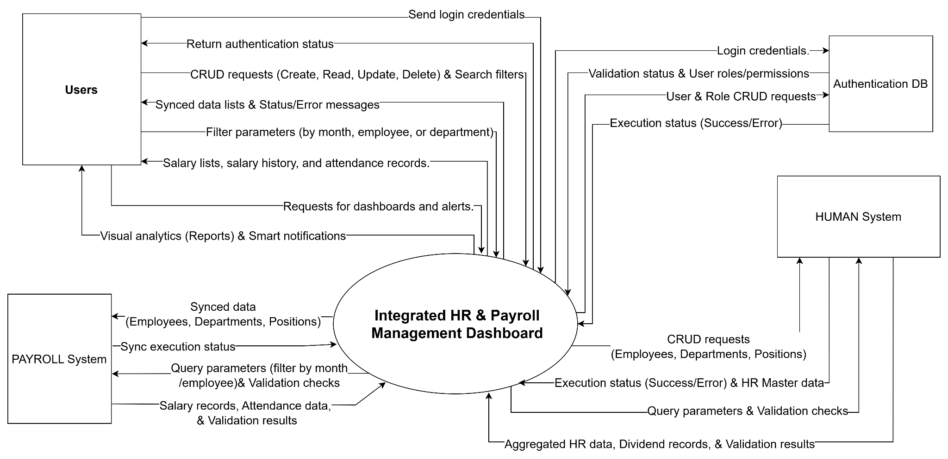

3.2 Product Functions
- Authentication & Security.
- Employee Management
- Department & Position Management.
- Payroll Management.
- Attendance Management.
- Reports & Analytics.
- Alerts & Notifications.

3.3 User Characteristics
User type | Describe | Skill
Admin | Manage users, assign roles/permissions, and configure the system. | Basic IT skills.
HR Manager | Manage employee profiles, contracts, and personnel. | HR operations / HR expertise.
Payroll Manager | Manage payroll, allowances, and deductions. | Financial operations / Finance expertise.
Employee | View personal profile, attendance history, and payroll records. | General user / Standard user.

3.4 Constraints
- The application is web-based and supports Chrome/Edge browsers.
- Complies with HR data privacy and security policies.

3.5 Assumptions and Dependencies
- Each employee has an email account for logging in and receiving notifications.
- The system depends on two databases: HUMAN_2025 and PAYROLL.
- A stable internet connection between the server and the client.

4. Specific Requirements

4.1 Functional Requirements
ID | Description of functional requirements | Priority level
FR1 | The system shall allow users to log in securely through a separate authentication system (Authentication DB). | High
FR2 | The system shall implement Role-Based Access Control (RBAC) for API and UI access based on user roles. | High
FR3 | The system shall allow users to view all employees, filter by department, position, or status, and search employees by name. | High
FR4 | The system shall allow adding a new employee to the HUMAN_2025 database and automatically synchronize the data to the employees_payroll table in the PAYROLL database. | High
FR5 | The system shall allow updating employee information and automatically synchronize the changes to the employees_payroll table. | High
FR6 | The system shall prevent the deletion of an employee if they have salary records in PAYROLL.salaries or dividend records in HUMAN_2025.Dividends. | High
FR7 | The system shall allow viewing, adding, updating, and deleting departments in HUMAN_2025 and synchronize the changes to the departments_payroll table in PAYROLL. | Medium
FR8 | The system shall allow viewing, adding, updating, and deleting positions in HUMAN_2025 and synchronize the changes to the positions_payroll table in PAYROLL. | Medium
FR9 | The system shall allow viewing the salary list and filtering data by month, employee, or department. | High
FR10 | The system shall allow viewing salary history and provide a payroll summary for dashboard reports. | Medium
FR11 | The system shall allow viewing attendance data, filtering by month or employee, and generating leave/absence analytics. | High
FR12 | The system shall generate HR reports including employee count, gender distribution, and department distribution. | Medium
FR13 | The system shall generate payroll reports including total salary cost, salary by department, and salary trend. | Medium
FR14 | The system shall generate attendance reports including leave/absence rate and monthly attendance summary. | Medium
FR15 | The system shall generate dividend reports including total dividends and dividends per employee. | Low
FR16 | The system shall automatically generate work anniversary alerts based on the HireDate field of employees. | Low
FR17 | The system shall automatically generate excessive leave alerts based on attendance data. | Medium
FR18 | The system shall automatically generate salary discrepancy alerts based on payroll data. | High

4.2 Non-functional Requirements
Type | Request
Performance | System response time shall be less than 2 seconds for all data retrieval operations.
Security | Passwords must be hashed using secure algorithms. All communications between the UI and API must be encrypted via HTTPS.
Reliability | The system shall maintain a minimum uptime of 99.5%. Database backups must be performed automatically on a daily basis.
Usability | The user interface (UI) shall be intuitive, allowing a new user to complete basic HR tasks within 30 minutes of training.
Scalability | The system shall support at least 500 concurrent users without any significant degradation in performance.

4.3 External Interface Requirements
- UI: Responsive web interface with Dashboard, Employee List, Payroll, and Reports features.
- DB:
  - SQL Server (HUMAN_2025).
  - MySQL (PAYROLL).
- API: The REST API returns JSON data.
- Security: SSL/TLS, JWT authentication.

5. System Models

5.1 Business Function Diagram (BFD)

5.2 List of Use Case
Use case ID | Use case name | Functional Req.
UC.001 | Login | FR01
UC.002 | Manage Users & Roles | FR02
UC.003 | View Employee List | FR03
UC.004 | Add New Employee | FR04
UC.005 | Update Employee Information | FR05
UC.006 | Delete Employee | FR06
UC.007 | Manage Departments | FR07
UC.008 | Manage Positions | FR08
UC.009 | View Salary List | FR09
UC.010 | View Salary History | FR10
UC.011 | View Attendance Data | FR11
UC.012 | View Dashboard Reports | FR12, FR13, FR14, FR15
UC.013 | View System Alerts | FR16, FR17, FR18

5.3 Use Case Diagram Overview
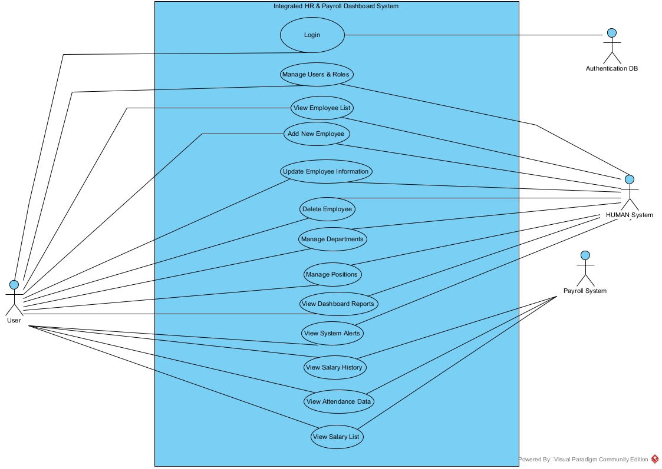

5.4 Use Case Specification:

Login Use Case
Use Case ID | UC.01
Use Case Name | System Login
Created by | Thong Le |  | Last updated by |  | Thong Le
Date Created | Mar 17, 2026 |  | Date last updated |  | Mar 18, 2026
Actors | User (Admin, HR Manager, Payroll Manager, Employee), Authentication System.
Brief Description | Users securely log into the system via an independent Authentication DB to receive an access token (JWT Token) corresponding to their role.
Goal | Authenticate the user's identity and grant access to the integrated Dashboard
Trigger | The user opens the application's login page and requests to log in.
Pre-conditions | - The Authentication DB system is functioning normally.  - The user has a valid account and role in the Roles table.
Post-conditions | - The user is issued a valid JWT token.  - The Dashboard UI is rendered according to role-based access
Main Flow | Step | Actor Action |  | System Response
 | 1 | Open the Dashboard login page. |  | Displays the login form, including Username and Password fields.
 | 2 | Enter a valid Username and Password.
 | 3 | Click the "Login" button to submit credentials. |  | API sends the credentials to the Authentication DB to hash and verify against the Users table.
 | 4 |  |  | Successful verification. The system retrieves the user's Role and generates a JWT Token.
 | 5 |  |  | Returns the JWT Token and redirects the user to the Dashboard homepage based on their permissions.
Alternative Flow | Alternative Flow 1: Invalid Credentials
 | Step | Actor Action |  | System Response
 | 1 | Open the login page. |  | Displays the login form.
 | 2 | Enters an invalid Username or Password.
 | 3 | Click the "Login" button. |  | Verifies credentials in the Authentication DB and finds no match.
 | 4 |  |  | Displays error message: "Invalid username or password. Please try again."
 | 5 | Re-enters credentials.
 | 6 | Click the "Login" button. |  | Repeats the verification process (returns to step 3 of the Main Flow).
 | Alternative Flow 2: Empty Fields
 | Step | Actor Action |  | System Response
 | 1 | Open the login page. |  | Displays the login form.
 | 2 | Leaves the Username or Password field empty.
 | 3 | Click the "Login" button. |  | Client/API validation rejects the request. Displays warning: "Please enter both Username and Password."
Exception Flow | Exception Flow 1: Database Connection Failure
 | Step | Actor Action |  | System Response
 | 1 | Open the login page. |  | Displays the login form, including Username and Password fields.
 | 2 | Enter Username and Password.
 | 3 | Click the "Login" button to submit credentials. |  | Attempts to verify the information but cannot access the database due to a lost connection.
 | 5 |  |  | Displays an error message: "Connection to the server failed. Please try again later."
 | 6 | Retries later or contacts the system administrator.
Priority | High
Business Rule | BR05, BR12

Manage Users & Roles Use Case
Use Case ID | UC.02
Use Case Name | Manage Users & Roles
Created by | Thong Le |  | Last updated by |  | Thong Le
Date Created | Mar 17, 2026 |  | Date last updated |  | Mar 18, 2026
Actors | Admin
Brief Description | Admin views the list, adds, updates, deletes user accounts, and assigns Roles in the Authentication DB
Goal | Manage system access rights and roles for all employees.
Trigger | Admin clicks on the "User Management" menu on the Dashboard.
Pre-conditions | Admin is successfully logged in, and the API request contains a JWT Token with Admin privileges.
Post-conditions | The Users and Roles tables in the Authentication DB are successfully updated.
Main Flow | Step | Actor Action |  | System Response
 | 1 | Clicks on the "User Management" menu. |  | API queries the Authentication DB to fetch the list of Users and Roles. Displays the list on the screen.
 | 2 | Clicks the "Add New User" button. |  | Displays the information form: Username, Password, Role, EmployeeID.
 | 3 | Fills in valid information and clicks "Save". |  | API receives data, validates it, and encrypts the Password.
 | 4 |  |  | Inserts new data into the Authentication DB.Users table.
 | 5 |  |  | Displays a success message "User added successfully" and refreshes the displayed list.
Alternative Flow | Alternative Flow 1: Update User Role
 | Step | Actor Action |  | System Response
 | 1 | Selects a User from the list and clicks "Edit". |  | Displays a form with the User's current information.
 | 2 | Changes the Role (e.g., from Employee to HR Manager) and clicks "Save". |  | API sends an Update command to the Users table to change the RoleID.
 | 3 |  |  | Displays a success message "Role updated successfully" and refreshes the list.
 | Alternative Flow 2: Delete Account
 | Step | Actor Action |  | System Response
 | 1 | Selects a User from the list and clicks "Delete Account". |  | Displays a warning dialog: "Are you sure you want to delete this account? This action cannot be undone."
 | 2 | Click "Confirm". |  | API sends a DELETE command to remove the User's record from the Authentication DB.
 | 3 |  |  | Displays a success message "Account deleted successfully" and refreshes the displayed list.
Exception Flow | Exception Flow 1: Username Already Exists
 | Step | Actor Action |  | System Response
 | 1 | Fills in new User information in the form.
 | 2 | Click "Save". |  | API checks the database and finds that the Username already exists in the system.
 | 3 |  |  | Prevents the save action. Displays an error message: "Username already exists. Please choose another one."
 | Exception Flow 2: Unauthorized Access Attempt
 | Step | Actor Action |  | System Response
 |  | (A non-Admin user attempts to call the /users management API). |  | API Layer decodes the JWT Token, checks the role, and detects the user lacks permission.
 |  |  |  | Returns an HTTP 403 Forbidden error: "You do not have permission to access this function."
Priority | High
Business Rule | BR04

View Employee List
Use Case ID | UC.03
Use Case Name | View Employee List
Created by | Vo Van Minh |  | Last updated by |  | Vo Van Minh
Date Created | Mar 17, 2026 |  | Date last updated |  | Mar 18, 2026
Actors | HR Manager, Admin
Brief Description | Allows users to view the entire list of employees in the system. Users can search by name or filter by department, position, or employment status to support effective personnel data management.
Goal | Display the employee list accurately and quickly.
Trigger | User access the "Employee List" menu from the dashboard or the system's navigation bar.
Pre-conditions | - The user is logged in.  - Authorized access (HR/Admin).  - Successful database connection.
Post-conditions | - Employee list is displayed.  - Data can be searched/filtered.  - No changes are made to the system data.
Main Flow | Step | Actor Action |  | System Response
 | 1 | The user opens the "Employee List" page. |  | Displays the employee list interface.
 | 2 | User requests to view the list. |  | System queries data from the database.
 | 3 |  |  | Displays employee list (ID, Name, Department, Position, Status).
 | 4 | The user enters keywords or selects filters. |  | System processes search/filtering.
 | 5 |  |  | Displays matching results.
 | 6 | User navigates pages (if any). |  | The system displays data by page.
Alternative Flow | Alternative Flow 1: Database Connection Error
 | Step | Actor Action |  | System Response
 | 1 | The user enters keywords or selects filters. |  | The system processes the query request.
 | 2 |  |  | No matching data found.
 | 3 |  |  | Displays message: “No employees match the search criteria”.
 | Alternative Flow 2: Large Data Set
 | Step | Actor Action |  | System Response
 | 1 | The user accesses the list. |  | System queries data.
 | 2 |  |  | The system paginates the data.
 | 3 | The user switches pages. |  | The system loads data for the next page.
Exception Flow | Exception Flow 1: Database Connection Error
 | Step | Actor Action |  | System Response
 | 1 | The user accesses the function. |  | The system sends the query request.
 | 2 |  |  | Unable to connect to the database.
 | 3 |  |  | Displays message: “System error, please try again later”.
 | 4 | Users can try again later or contact the administrator.
 | Exception Flow 2: User Unauthorized
 | Step | Actor Action |  | System Response
 | 1 | The user accesses the function. |  | The system sends the query request.
 | 2 |  |  | Unable to connect to the database.
 | 3 |  |  | Displays message: “System error, please try again later”.
Priority | High
Business Rule | BR-03

Add New Employee
Use Case ID | UC.04
Use Case Name | Add Employee
Created by | Doan Ba Rin |  | Last updated by |  | Doan Ba Rin
Date Created | Mar 17, 2026 |  | Date last updated |  | Mar 18, 2026
Actors | HR, Admin
Brief Description | Allow users to add employees in the HUMAN system and PAYROLL.
Goal | Ensure consistency between HUMAN and PAYROLL.
Trigger | Users choose “Add Employee” on the dashboard.
Pre-conditions | - Users logged in.  - Have access rights.  - The system works normally.  - Database connects successfully.
Post-conditions | - The system can show a list of employees.  - Users can enter information into data fields.  - Employees add successfully and merge with HUMAN and PAYROLL database.
Main Flow | Step | Actor Action |  | System Response
 | 1 | Users choose “Add Employee”. |  | Show input data fields.
 | 2 | Enter data. |  | Check input data.
 | 3 | Users choose “Confirm". |  | Update into database.
 | 4 |  |  | Show “Add successfully”
Alternative Flow | Cancel “Add employee process”
 | Step | Actor Action |  | System Response
 | 1 | Users choose “Add Employee”. |  | Show input data fields.
 | 2 | Enter data. |  | Check input data.
 | 3 | Users choose “Back” |  | Go back to the dashboard homepage.
Exception Flow | Invalid Input
 | Step | Actor Action |  | System Response
 | 1 | Enter data. |  | Check input data.
 | 2 |  |  | Wrong data/ Missing important input.
 | 3 |  |  | Show “Error, You enter wrong data or missing important input.
 | 4 | Có thể thử lại sau hoặc liên hệ với quản trị viên.
 | Duplicate Data
 | Step | Actor Action |  | System Response
 | 1 | User add employee. |  | System check input data with database
 | 2 |  |  | Data(Email, phone number,..) already exist.
 | 3 |  |  | Show “The employee data already exist.
 | 4 | Change data and try again.
Priority | High
Business Rule | BR01, BR02, BR03

Update Employee Information
Use Case ID | UC.05
Use Case Name | Edit Employee Information
Created by | Doan Ba Rin |  | Last updated by |  | Doan Ba Rin
Date Created | Mar 17, 2026 |  | Date last updated |  | Mar 18, 2026
Actors | HR, Admin
Brief Description | Allow users to edit employees information in the HUMAN system and PAYROLL.
Goal | Ensure consistency between HUMAN and PAYROLL.
Trigger | Users choose “Edit Employee Information” on the dashboard.
Pre-conditions | - Users logged in.  - Have access rights.  - The system works normally.  - Database connects successfully.
Post-conditions | - The system can show a list of employees.  - Users can enter information into data fields.  - Employees add successfully and merge with HUMAN and PAYROLL database.
Main Flow | Step | Actor Action |  | System Response
 | 1 | Users choose “Update Information”. |  | Show employees list.
 | 2 | Users search for employees. |  | Show search employees data.
 | 3 | Enter data. |  | Check data input.
 | 4 | Users choose “Confirm”. |  | Update into database.
 | 5 |  |  | Show“Information update successfully”.
Alternative Flow | User does not change data
 | Step | Actor Action |  | System Response
 | 1 | Users choose “Update Information”. |  | Show employees list.
 | 2 | Users search for employees. |  | Show search employees data.
 | 3 | Not enter data. |  | Check data input.
 | 4 | Users choose “Confirm”.. |  | Show“There is no change has been made”
 | Cancel Edit Information
 | 1 | Users choose “Update Information”. |  | Show employees list.
 | 2 | Users search for employees. |  | Show search employees data.
 | 3 | Users choose “Back”. |  | Go back to the dashboard homepage.
Exception Flow | Employee does not exist
 | Step | Actor Action |  | System Response
 | 1 | Users choose “Update Information”. |  | Show employees list.
 | 2 | Users search for employees |  | Show search employees data.
 | 3 |  |  | Show “Employee is not exist”
 | 4 | Change search input and try again.
 | Duplicate Data
 | Step | Actor Action |  | System Response
 | 1 | Users choose “Update Information”. |  | Show employees list.
 | 2 | Users search for employees |  | Show search employees data.
 | 3 | Enter data. |  | Check input data.
 | 4 |  |  | Data(Email, phone number,..) already exist.
 | 5 |  |  | Show “Employee data is already exist”
 | 6 | Change input data and try again.
Priority | High
Business Rule | BR-01, BR-02, BR-03

Delete Employee
Use Case ID | UC.06
Use Case Name | Edit Employee Information
Created by | Doan Ba Rin |  | Last updated by |  | Doan Ba Rin
Date Created | Mar 17, 2026 |  | Date last updated |  | Mar 18, 2026
Actors | HR, Admin
Brief Description | Allow users to delete employees in the HUMAN system and PAYROLL.
Goal | Ensure consistency between HUMAN and PAYROLL.
Trigger | Users choose “Delete Employee” on the dashboard.
Pre-conditions | - Users logged in.  - Have access rights.  - The system works normally.  - Database connects successfully.
Post-conditions | - The system can show a list of employees.  - Users can enter information into data fields.  - Employees add successfully and merge with HUMAN and PAYROLL database.
Main Flow | Step | Actor Action |  | System Response
 | 1 | Users choose “Delete Employee”. |  | Show employee list.
 | 2 | Users search for employees |  | Show search employees data.
 | 3 | User choose “Confirm Delete” |  | Show “Do you want to delete this employee”
 | 4 | User choose “Confirm” |  | Update into database.
 | 5 |  |  | Show“Delete successfully”
Alternative Flow | Cancel Delete
 | 1 | Users choose “Delete Employee”. |  | Show employee list.
 | 2 | Users search for employees |  | Show search employees data.
 | 3 | User choose “Back” |  | Go back to dashboard homepage
Exception Flow | Can’t be delete ( Employee has constraints )
 | Step | Actor Action |  | System Response
 | 1 | User delete employee |  | System check for constraint.
 | 2 |  |  | Employee has constraint.
 | 3 |  |  | Show “Can’t be deleted, employee has constraint”.
Priority | High
Business Rule | BR-01, BR-02, BR-03

Manage Departments
Use Case ID | UC.07
Use Case Name | Manage Departments
Created by | Vo Van Minh |  | Last updated by |  | Vo Van Minh
Date Created | Mar 17, 2026 |  | Date last updated |  | Mar 18, 2026
Actors | HR Manager, Admin
Brief Description | Allows users to view, add, edit, or delete department information in the HUMAN_2025 system and automatically synchronize it with the PAYROLL system.
Goal | Manage the organizational structure and ensure department data consistency between the two databases.
Trigger | The user selects the “Manage Departments” function from the navigation bar.
Pre-conditions | - User is logged in.  - User has access rights (HR Manager/Admin).  - The system is operating normally.  - Database connection is successful.
Post-conditions | - Department information is updated in HUMAN_2025.  - Data is successfully synchronized to PAYROLL.
Main Flow | Step | Actor Action |  | System Response
 | 1 | User selects “Manage Department”. |  | Displays department list interface.
 | 2 | User selects a function (Add/Edit/Delete). |  | System displays the corresponding form.
 | 3 | User enters or edits information. |  | System validates the data.
 | 4 | User confirms save. |  | System updates the database.
 | 5 |  |  | Displays the updated department list.
Alternative Flow | Sub-flow 1: Add Department
 | Step | Actor Action |  | System Response
 | 1 | User selects “Add Department”. |  | Displays add form.
 | 2 | User enters information. |  | System validates.
 | 3 |  |  | Saves data successfully.
 | 4 |  |  | Displays the new department.
 | Sub-flow 2: Edit Department
 | Step | Actor Action |  | System Response
 | 1 | Sub-flow 2: Edit Department |  | System displays information.
 | 2 | User edits. |  | System validates.
 | 3 |  |  | Updates data.
 | 4 |  |  | Displays updated information.
 | Sub-flow 3: Delete Department
 | 1 | User selects “Delete”. |  | System requests confirmation.
 | 2 | User confirms. |  | System deletes data.
 | 3 |  |  | Updates the list.
Exception Flow | Exception 1: Invalid Data
 | Step | Actor Action |  | System Response
 | 1 | User enters data. |  | System validates.
 | 2 |  |  | Data is invalid/missing.
 | 3 |  |  | Displays error message: “Error”.
 | 4 | User can retry or contact administrator.
 | Exception 2: Cannot Delete
 | Step | Actor Action |  | System Response
 | 1 | User deletes a department. |  | System checks.
 | 2 |  |  | Department is currently in use.
 | 3 |  |  | Displays message: “Cannot delete”.
Priority | High
Business Rule | BR02, BR06

Manage Positions
Use Case ID | UC.08
Use Case Name | Manager Positions
Created by | Vo Van Minh |  | Last updated by |  | Vo Van Minh
Date Created | Mar 17, 2026 |  | Date last updated |  | Mar 18, 2026
Actors | HR, Admin
Brief Description | Allows users to view, add, edit, or delete positions in the HUMAN_2025 system and automatically synchronize with the PAYROLL system.
Goal | Ensure that the position list is accurate and consistent between the HR and payroll systems.
Trigger | The user selects the “Manage Positions” function from the navigation bar.
Pre-conditions | - User is logged in.  - User has access rights (HR Manager/Admin).  - The system is operating normally.  - Database connection is successful.
Post-conditions | - The list of information is displayed.  - Users can search/filter data.  - Data is successfully synchronized.
Main Flow | Step | Actor Action |  | System Response
 | 1 | User selects “Manage Positions”. |  | Display the list of positions.
 | 2 | User chooses a function (Add/Edit/Delete). |  | Display the corresponding form.
 | 3 | User enters or edits information. |  | System validates the data
 | 4 | User confirms saving. |  | System updates the database.
 | 5 |  |  | Display the updated list.
Alternative Flow | Sub-flow 1: Add Position
 | Step | Actor Action |  | System Response
 | 1 | User selects “Add Positions”. |  | Display new form.
 | 2 | User enters position information. |  | System validates.
 | 3 |  |  | Save data successfully to the system.
 | 4 |  |  | Display the new position in the list.
 | Sub-flow 2: Edit Position
 | Step | Actor Action |  | System Response
 | 1 | User selects edit function. |  | Display current information.
 | 2 | User edits data. |  | System validates validity.
 | 3 |  |  | Update new data to the system.
 | 4 |  |  | Display updated information.
 | Sub-flow 3: Delete Position
 | 1 | User selects “Delete”. |  | System requests delete confirmation.
 | 2 | User confirms. |  | System deletes data from database.
 | 3 |  |  | Update displayed list.
Exception Flow | Exception 1: Invalid Data
 | Step | Actor Action |  | System Response
 | 1 | User inputs data. |  | System validates.
 | 2 |  |  | Invalid data / Missing required fields.
 | 3 |  |  | Display message: “Error: Please check the information again”.
 | 4 | User retries or contacts administrator.
 | Exception 2: Cannot Delete (Data Constraint)
 | Step | Actor Action |  | System Response
 | 1 | User attempts to delete position. |  | System checks constraints.
 | 2 |  |  | Position is currently in use (assigned to employees).
 | 3 |  |  | Display: “Cannot delete: Position is currently assigned to employees”.
Priority | High
Business Rule | BR02, BR06

View Salary List
Use case ID | UC.009
Use case name | View Salary List
Create by | Su Phat Tai | Last updated by | Su Phat Tai
Date created | Mar 17, 2026 | Date last updated | Mar 18, 2026
Actor | Admin, Manager
Description | This allows users to view an overall payroll list, filter by criteria, and observe the company's payroll expense trend chart.
Trigger | The user clicks to view the payroll.
Pre-condition | View successful
Post-condition | Display data about payroll lists.
Main Scenario: | Successful Salary List Retrieval
 | Step | Actor Action | System Response
 | 1 | Click on the "Salary List" or "Payroll Dashboard" button on the main navigation menu. | Displays the Payroll Management interface with a list of all employees and their corresponding salary status.
 | 2 | Select the desired Month and Year from the dropdown filters. | Queries the PAYROLL database for records matching the selected time period.
 | 3 | Click the "Filter" or "Apply" button. | Validates the request and renders the updated salary list, including Net Salary, Gross Salary, and Status (Paid/Pending).
 | 4 | Click on the "View Details" icon for a specific employee. | Retrieves detailed line items (Base pay, Bonuses, Deductions) and displays them in a Modal/Pop-up window.
 | 5 | The user clicks on the "Details" icon of an employee. | The system displays a pop-up window containing the detailed payslip for that employee.
Alternative Scenario | Search and Filter by Department
 | Step | Actor Action | System Response
 | 1 | User selects a specific Department from the filter bar. | System updates the query parameters to include the Department ID
 | 2 | User enters an employee's name in the Search bar | System performs a real-time search within the currently filtered results.
 | 3 | User clicks "Apply" | System displays only the employees belonging to that department or matching the search name.
 | 4 | User clicks "Clear Filters" | System resets all filters and returns to the default full salary list
 | Exporting Salary List
 | Step | Actor Action | System Response
 | 1 | After filtering the list, the user clicks the "Export" button. | displays two options: "Export to Excel" and "Export to PDF"
 | 2 | User selects the format they want. | The system compiles the current table data into a format selected by the user.
 | 3 | User opens the downloaded file | System ensures the file content matches the filtered data on the UI.
 | E2: No Data Found
 | Step | Actor Action | System Response
 | 1 | User selects a month/year that has no payroll records | System queries the PAYROLL database and returns an empty result set.
 | 2 |  | System displays a warning message: "No payroll records found for the selected period."
 | 3 | User clicks "Close" or selects a different period | System returns to the state before the filter was applied
Exception Flow | Data Synchronization Failure
 | Step | Actor Action | System Response
 | 1 | User clicks "Apply Filter" | System detects that some employees in HUMAN_2025 are missing from the PAYROLL table for that month
 | 2 |  | System halts the display and shows an error: "Data integrity error: Some employee records are not synchronized. Please contact the Admin."
 | 3 | User clicks "Retry Sync" (if available) or contacts support | System logs the synchronization error for troubleshooting
Priority
Business Rule | BR7, BR11

View Salary History
Use case ID | UC.010
Use case name | View Salary History
Create by | Su Phat Tai | Last updated by | Su Phat Tai
Date created | Mar 17, 2026 | Date last updated | Mar 18, 2026
Actor | Admin, Manager
Description | Check your payroll history over different periods to cross-check or reprint old payslips.
Trigger | The user clicks to View Salary History.
Pre-condition | View successful
Post-condition | Display data about Salary history.
Main Scenario: | Successful Individual Salary History Retrieval
 | Step | Actor Action | System Response
 | 1 | Select an employee from the Employee List or go to "My Profile". | System identifies the unique Employee ID from the HUMAN_2025 database.
 | 2 | Click on the "Salary History" tab/button. | System sends a request to the PAYROLL database to fetch all records linked to that Employee ID.
 | 3 |  | System renders a chronological list of all previous payslips, starting from the most recent month.
 | 4 | Click on the "View" icon for a specific month | System displays a detailed breakdown: Base Salary, Overtime, Bonuses, Insurance, Tax, and Net Pay.
 | 5 | Click "Close" or "Back" to return to the history list. | System closes the detailed view and restores the previous list state
Alternative Scenario | Filter History by Year
 | Step | Actor Action | System Response
 | 1 | User selects a specific Year from the filter dropdown | System filters the local data or re-queries the database for that specific year.
 | 2 | User clicks "Search" | System updates the table to show only salary records belonging to the selected year.
 | 3 | User clicks "Reset" | System clears the year filter and displays the full history again.
 | Download Multiple Payslips
 | Step | Actor Action | System Response
 | 1 | User selects multiple checkboxes corresponding to different months. | System keeps track of the selected IDs in a temporary buffer.
 | 2 | User clicks the "Download Selected (PDF)" button. | System generates a combined PDF file or a ZIP folder containing individual payslips.
 | 3 |  | System displays a progress bar and initiates the download once processing is complete.
 | E1: Unauthorized Access Attempt
 | Step | Actor Action | System Response
 | 1 | User attempts to manually change the EmployeeID in the URL to a different ID | System's Role-Based Access Control interceptor checks the request.
 | 2 | System detects that the user's role/ID does not match the requested resource. | System denies the request and redirects the user to a "403 Forbidden" page.
Exception Flow | 3 |  | System logs this as a "Security Alert" in the audit log.
 | E2: Session Timed Out
 | Step | Actor Action | System Response
 | 1 | User stays inactive for more than 30 minutes, then clicks "View" | System checks the JWT Token and finds it has expired.
 | 2 |  | System invalidates the current session and clears the local storage/cookies.
 | 3 |  | System redirects the user to the Login Page with the message: "Your session has expired. Please login again to continue."
 | E3: No History Available
 | Step | Actor Action | System Response
 | 1 | User clicks on "Salary History" for a newly hired employee. | System finds zero records in the PAYROLL database for this ID.
 | 2 |  | System displays a friendly message: "No salary history available for this employee yet."
Priority
Business Rule | BR07, BR11

View Attendance Data
Use case ID | UC.011
Use case name | View Attendance Data
Create by | Su Phat Tai | Last updated by | Su Phat Tai
Date created | Mar 17, 2026 | Date last updated | Mar 18, 2026
Actor | HR Staff, Admin
Description | Manage attendance data, enter leave requests, and generate analytics on absenteeism rates.
Trigger | The user clicks to View Attendance Data.
Pre-condition | View successful
Post-condition | Display data about Attendance.
Main Scenario: | View Attendance Data
 | Step | Actor Action | System Response
 | 1 | Click on the "Attendance & Leave" menu on the Dashboard. | System queries the HUMAN_2026 and PAYROLL databases for current attendance records.
 | 2 |  | System displays the Attendance Overview dashboard (Daily/Monthly view).
 | 3 | Click the "Import Logs" button to upload data from the time-keeping machine. | System opens a file browser to select .csv or .xlsx files.
 | 4 | Select the file and click "Upload & Process". | System parses the file, matches Employee IDs, and updates the attendance_data table.
 | 5 | Click "Generate Leave Analytics". | System calculates and renders charts for absence rates and leave distribution (FR11 & FR14).
Alternative Scenario | A1: Manual Leave Request Entry
 | Step | Actor Action | System Response
 | 1 | User clicks the "Add Leave Request" button. | System displays a form: Employee Name, Leave Type (Annual, Sick, Unpaid), Start/End Date.
 | 2 | User enters the details and clicks "Submit". | System checks the Leave Balance for that employee in the database.
 | 3 |  | System saves the record and displays: "Leave request created and synchronized successfully."
 | A2: Export Monthly Attendance Report
 | Step | Actor Action | System Response
 | 1 | User filters the data by Month and Department. | System filters the records accordingly.
 | 2 | User clicks the "Export Report" button and selects PDF. | System generates a formatted attendance summary for the selected department.
 | E1: Excessive Leave Warning
 | Step | Actor Action | System Response
 | 1 | User enters a leave period (e.g., 5 days) that exceeds the employee's remaining balance (e.g., 2 days). | System triggers a warning: "Warning: Leave balance exceeded. Proceed as 'Unpaid Leave' for the remaining 3 days?"
 | 2 | User clicks "Confirm". | System splits the record and marks the excess days as Unpaid.
 | E2: Invalid File Format or Data Mismatch
 | Step | Actor Action | System Response
 | 1 | User uploads a file with missing columns or invalid Employee IDs. | System stops the import process.
 | 2 | System displays: "Error: Column 'EmployeeID' not found. Please use the system template."
 | 3 |  | System redirects the user to the Login Page with the message: "Your session has expired. Please login again to continue."
 | E3: Duplicate Record Detection
 | Step | Actor Action | System Response
 | 1 | User uploads logs that have already been imported for the same date. | System detects existing entries in the database.
 | 2 | System asks: "Duplicate records found. Skip duplicates or overwrite existing data?"
Priority
Business Rule | BR09

View Dashboard Reports
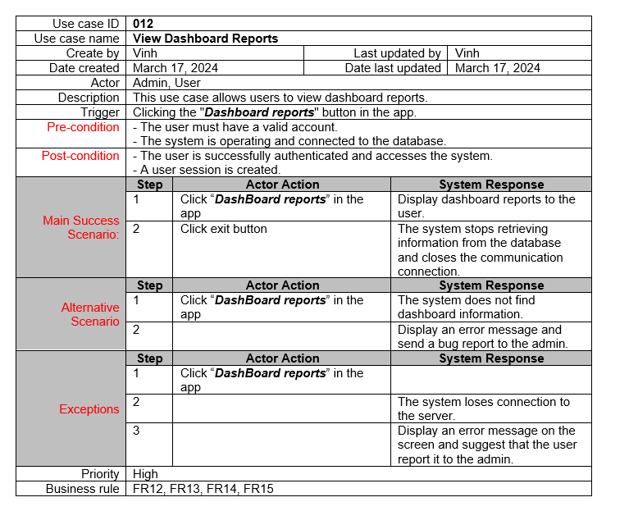
View System Alerts
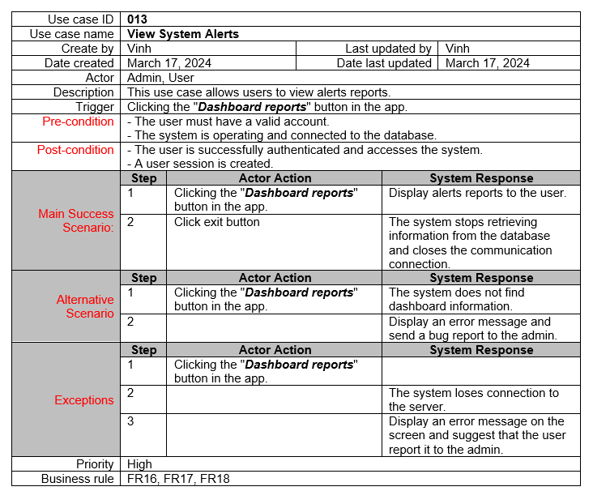

5.5 Activity Diagram

Login Use Case
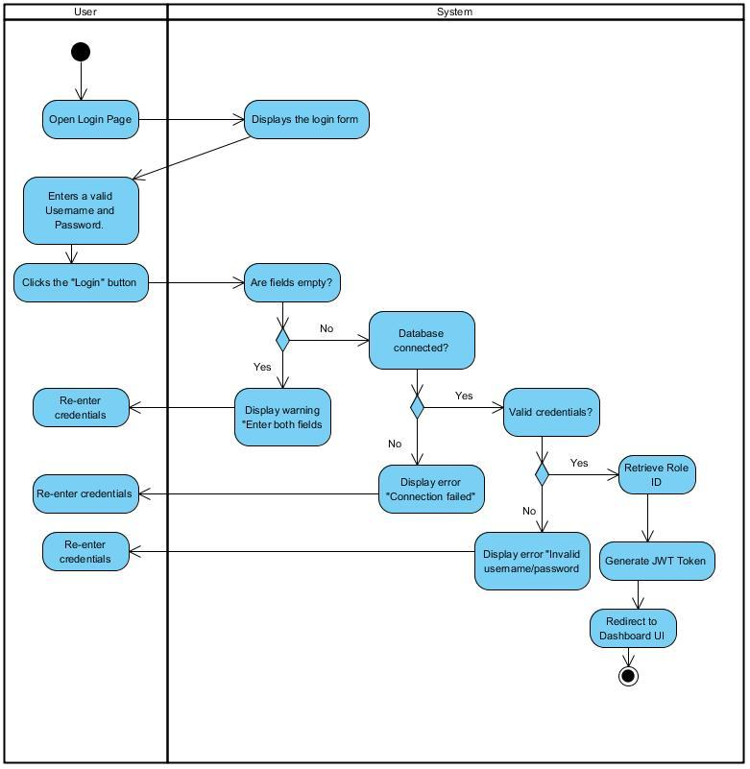

Manage Users & Roles Use Case
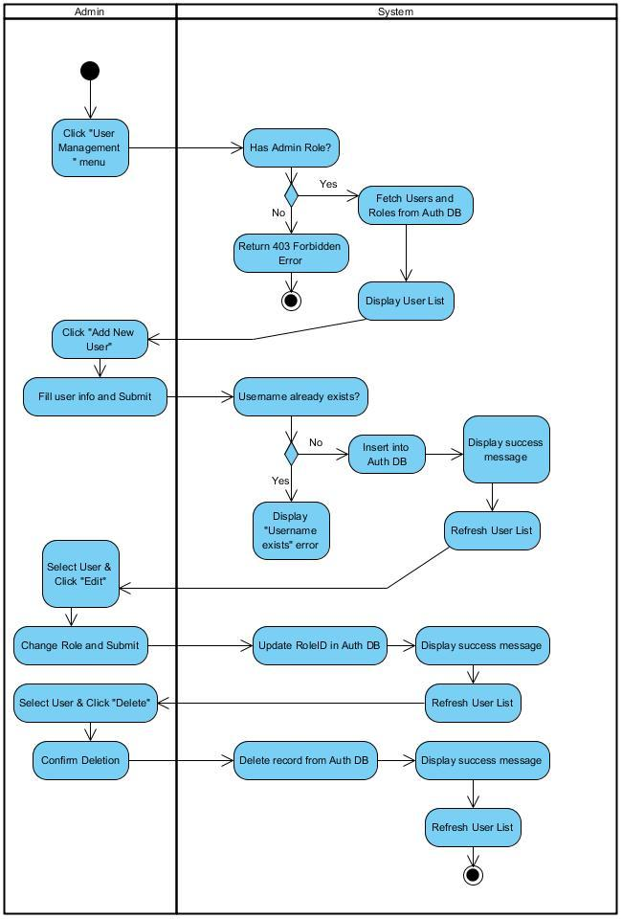

View Employee List
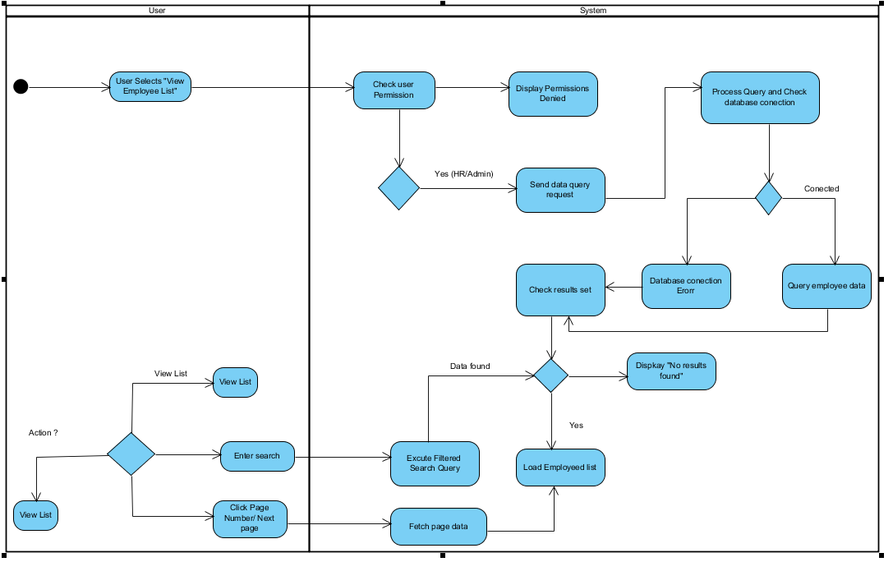
Add New Employee
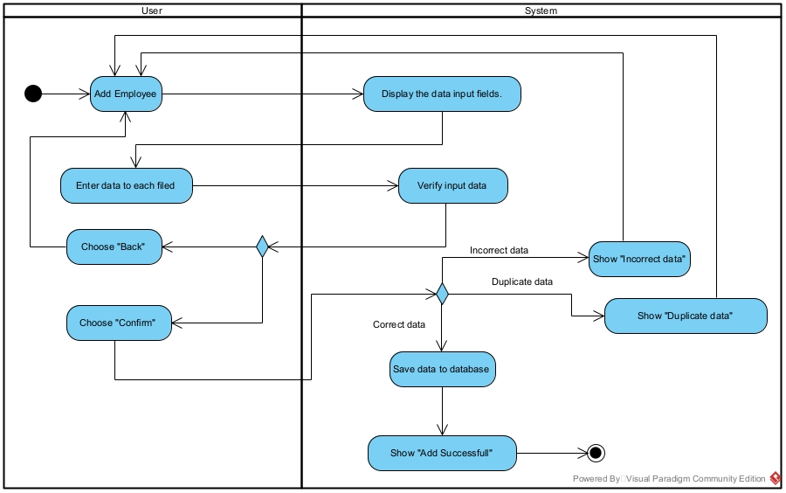
Update Employee Information
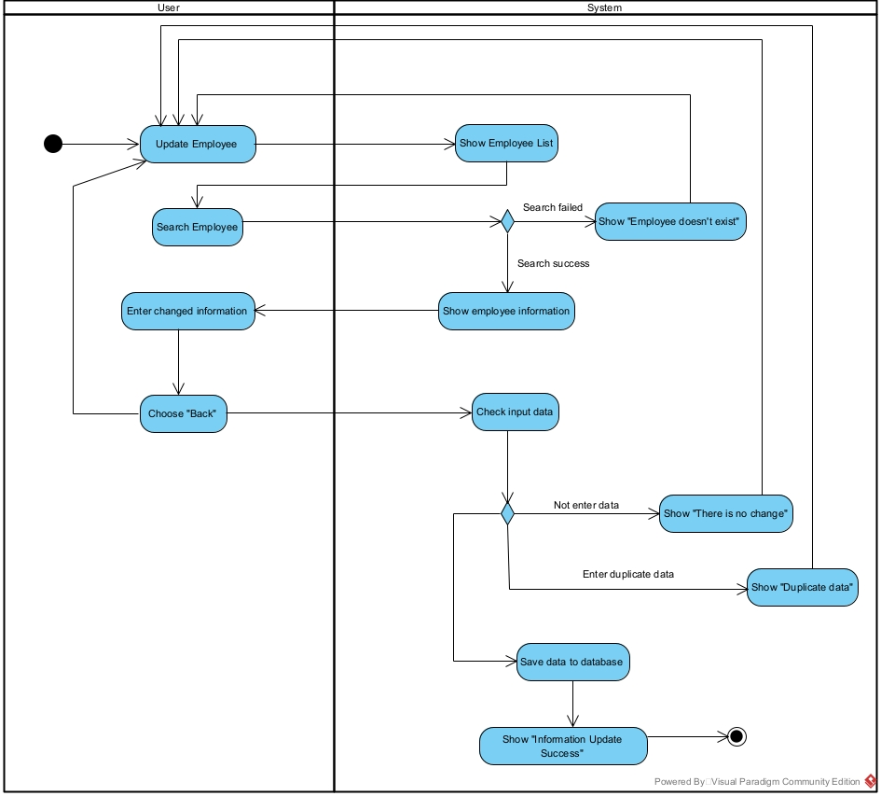
Delete Employee
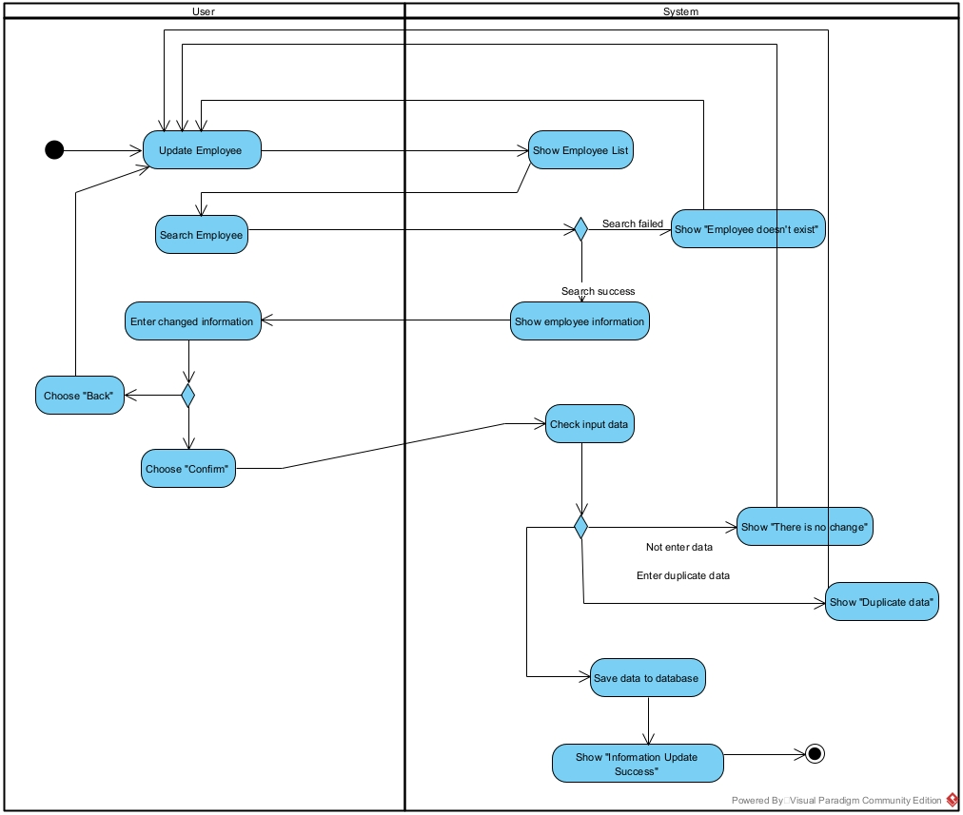
Manage Departments
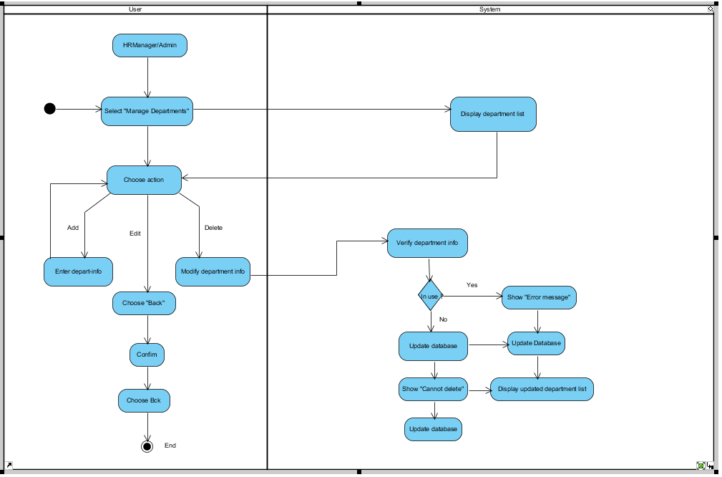
Manage Positions
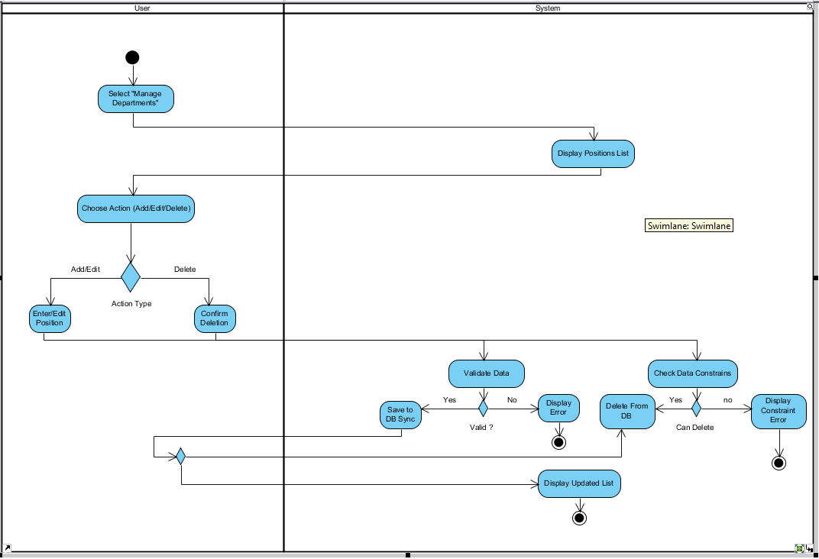

View Salary List
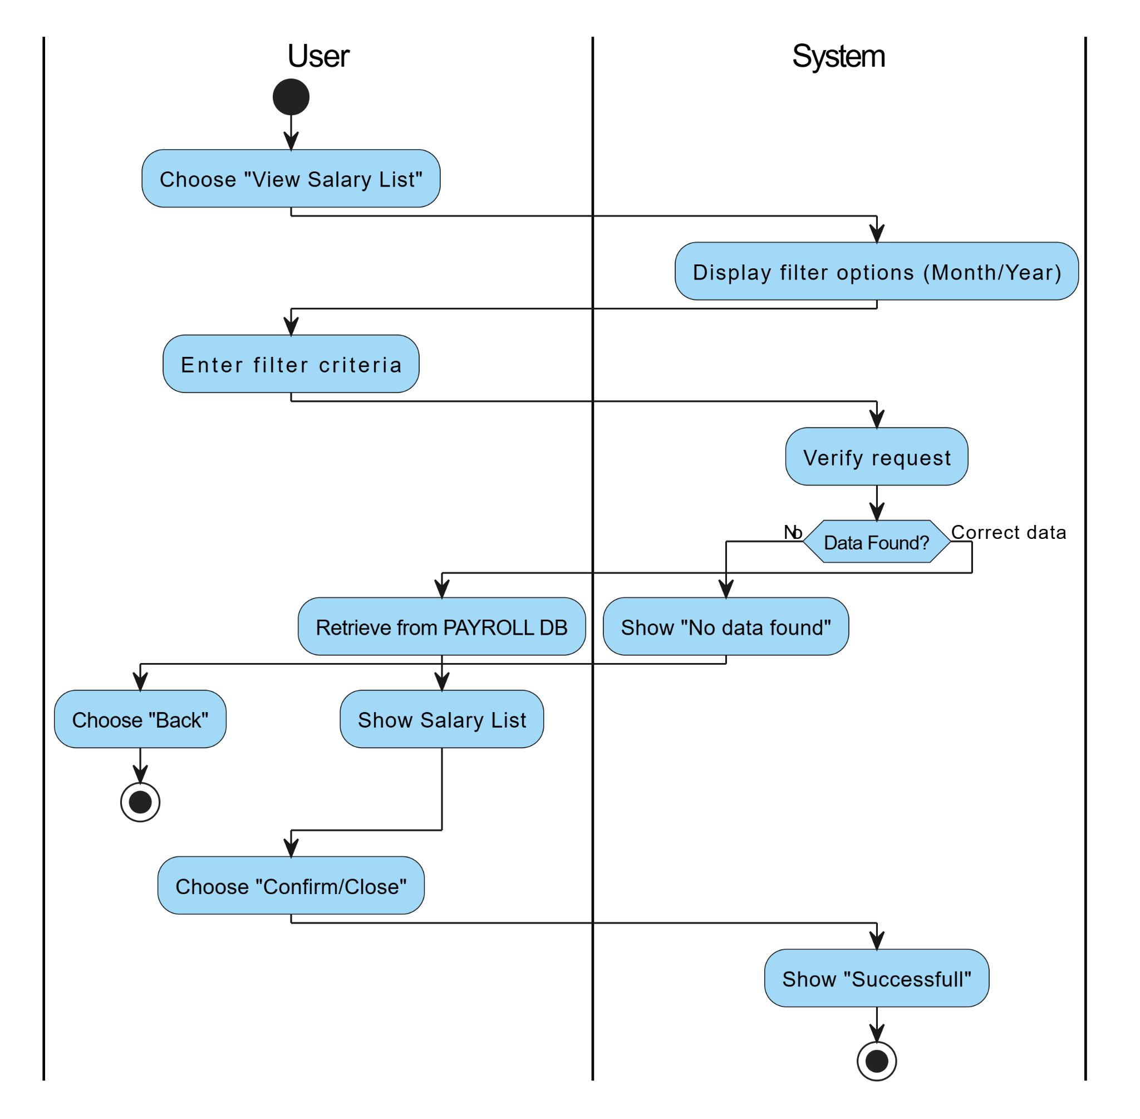

View Salary History
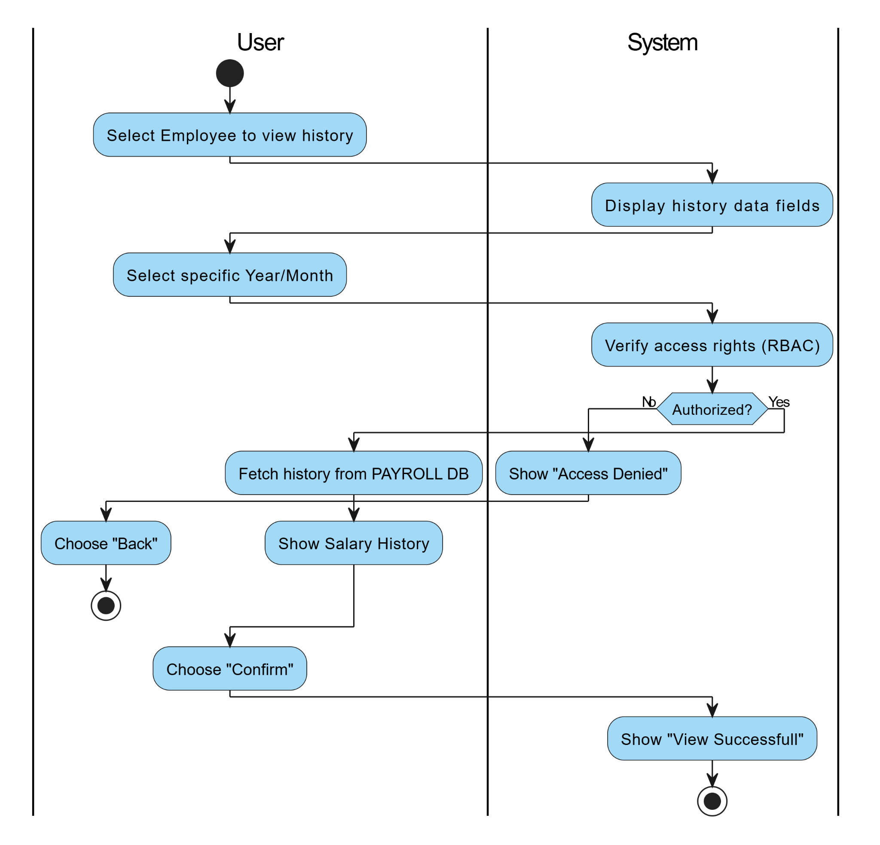
View Attendance Data
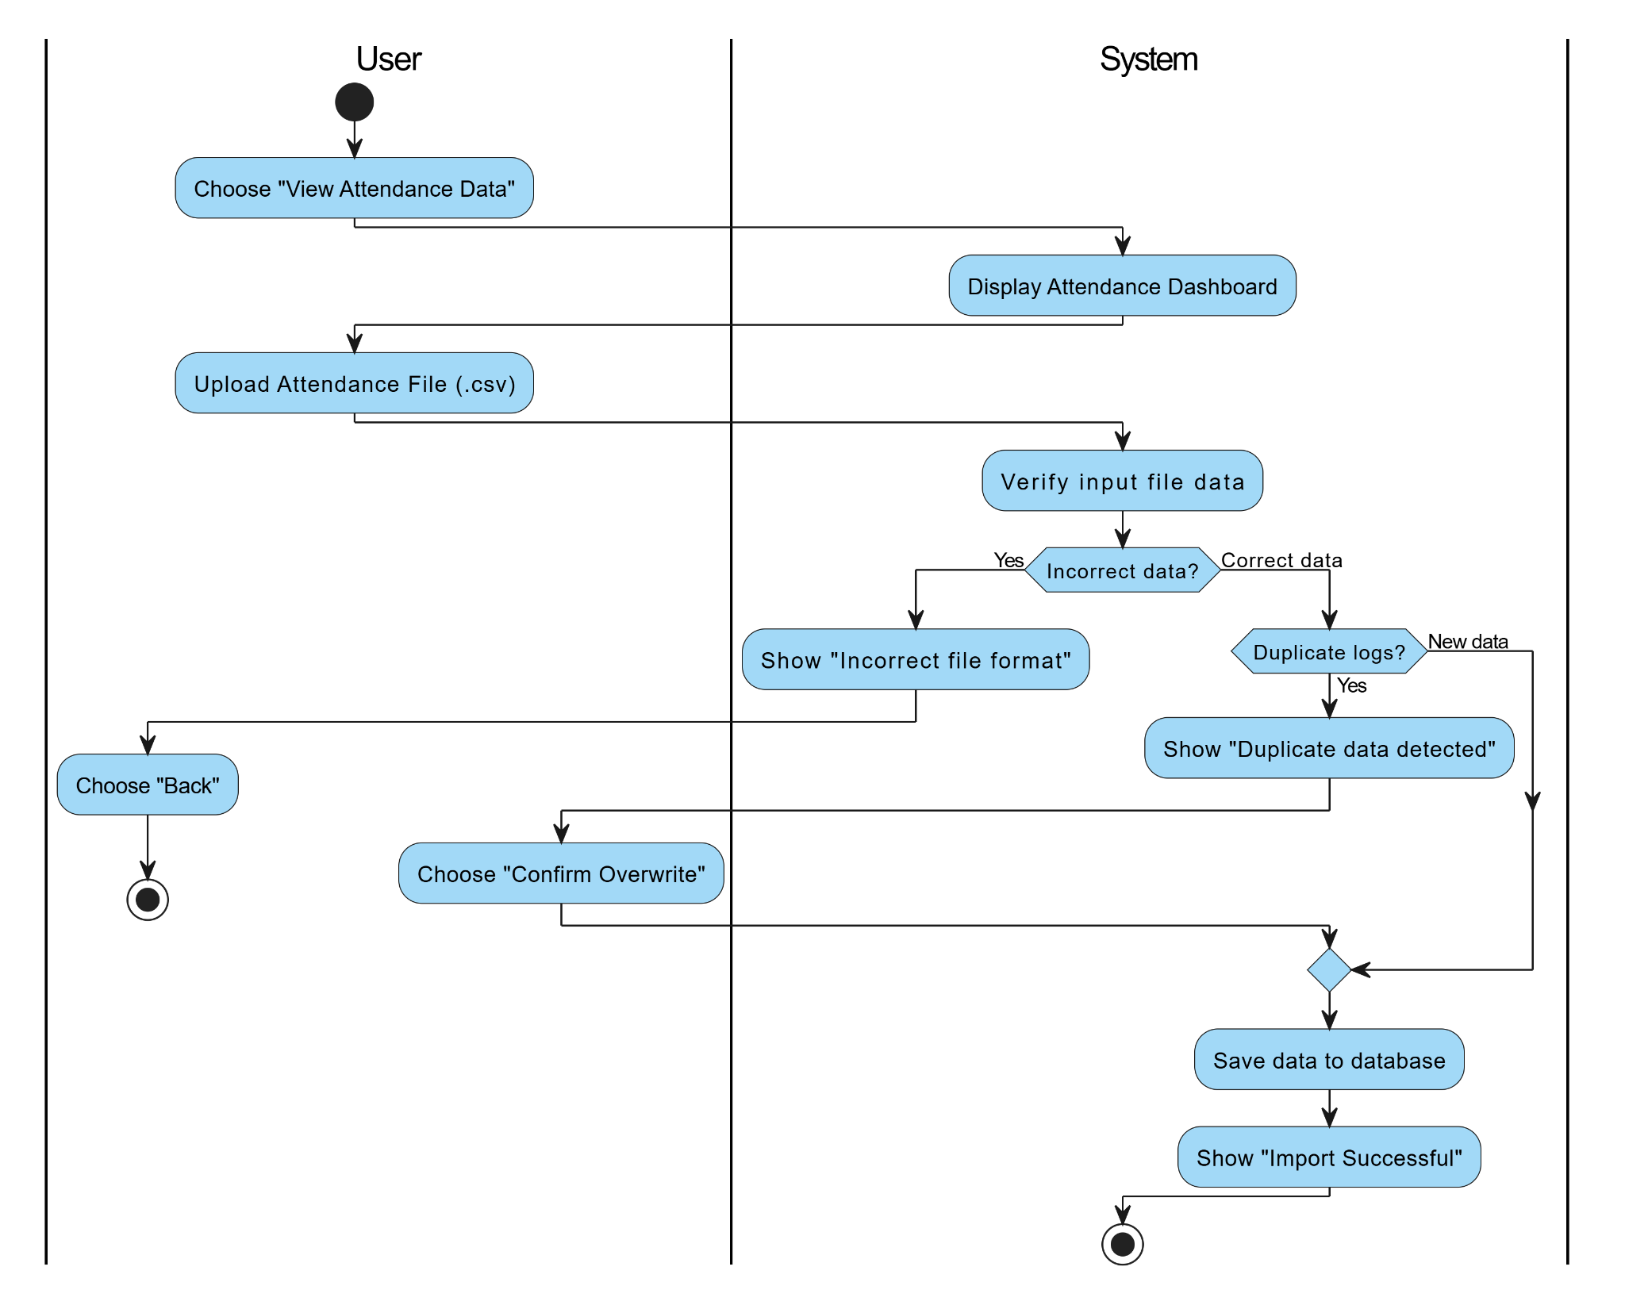
View Dashboard Reports
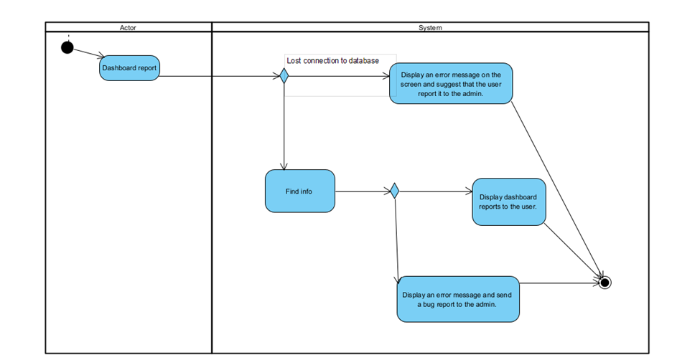
View System Alerts
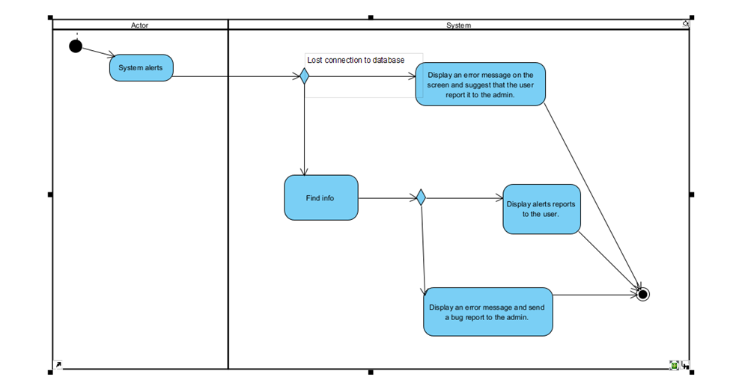

5.6 Sequence Diagram

Login Use Case
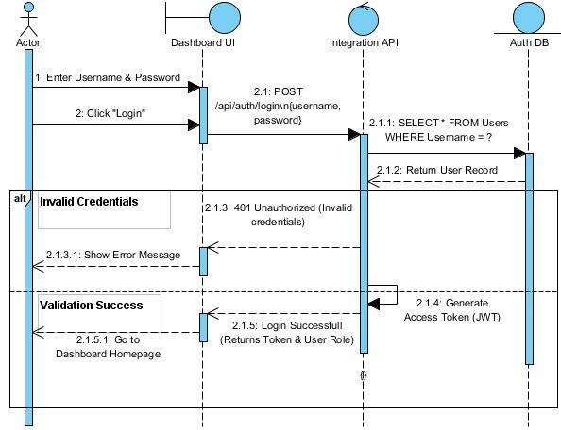

Manage Users & Roles Use Case
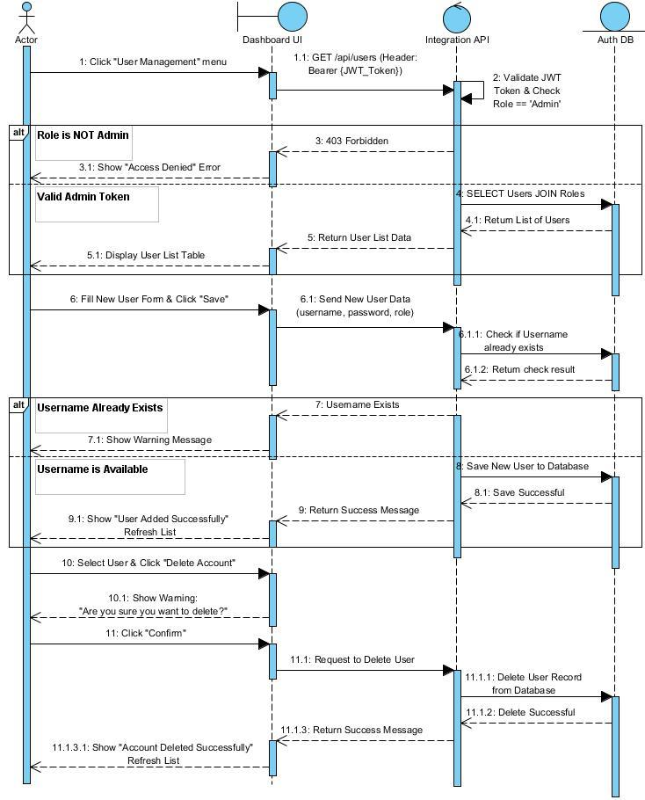

View Employee List
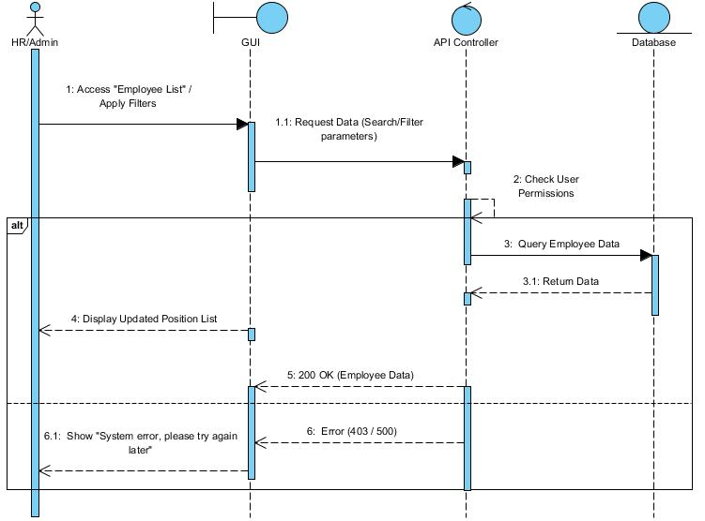

Add New Employee
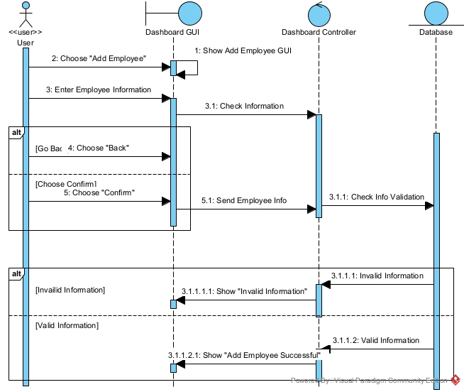
Update Employee Information
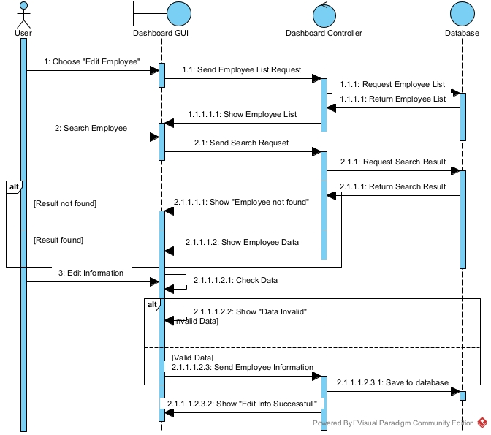

Delete Employee
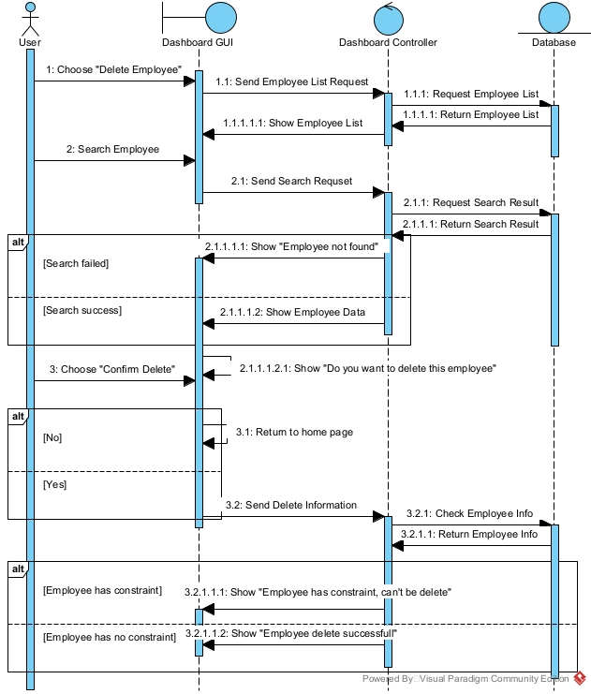

Manage Departments
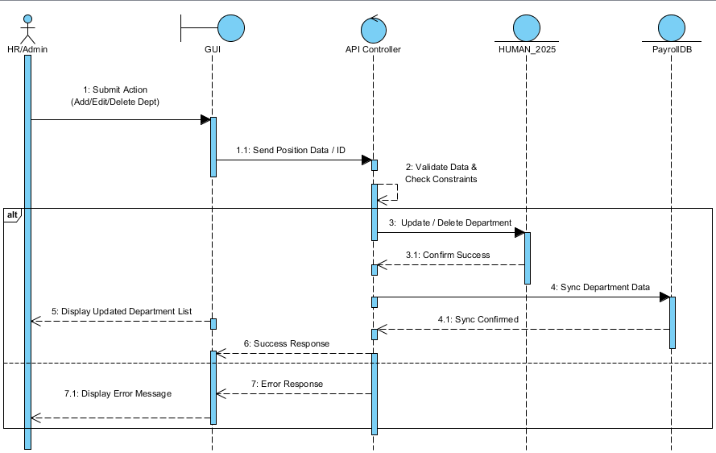
Manage Positions
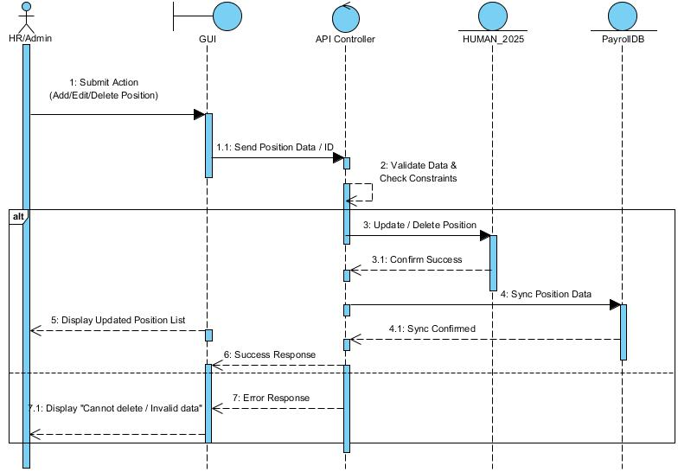
View Salary List
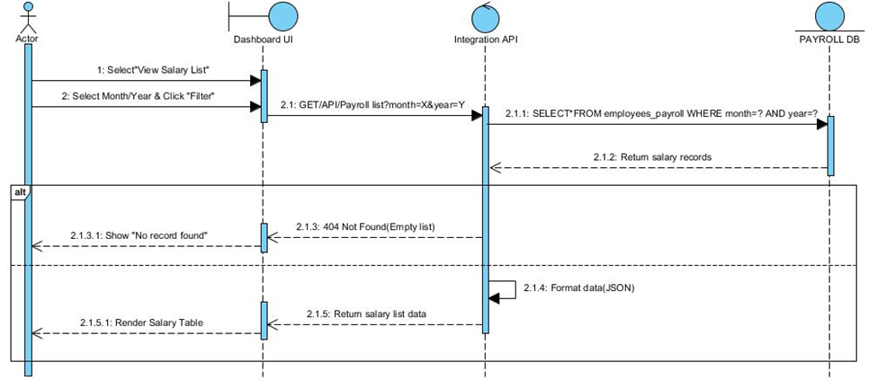
View Salary History
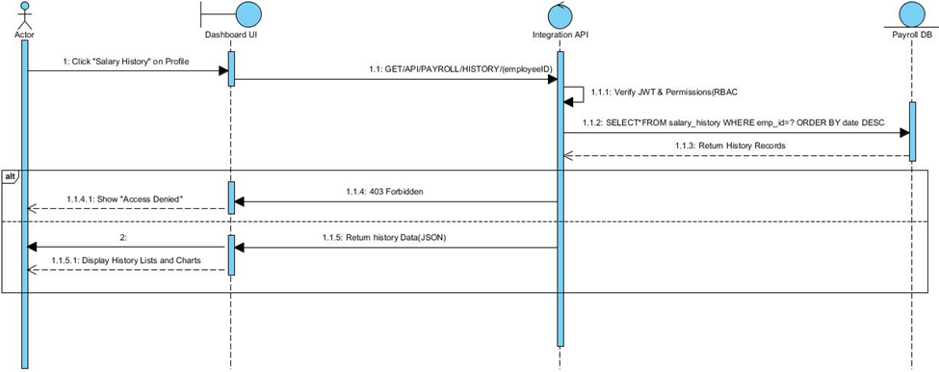

View Attendance Data
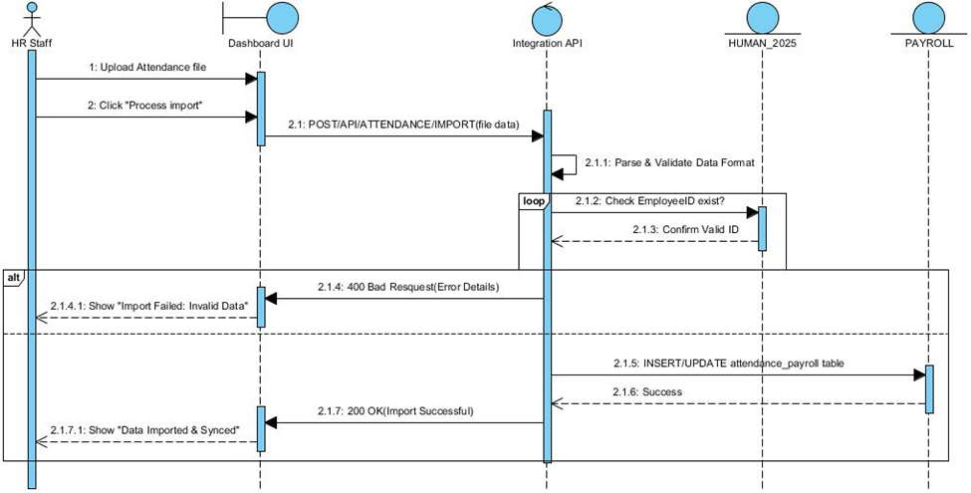
View Dashboard Reports
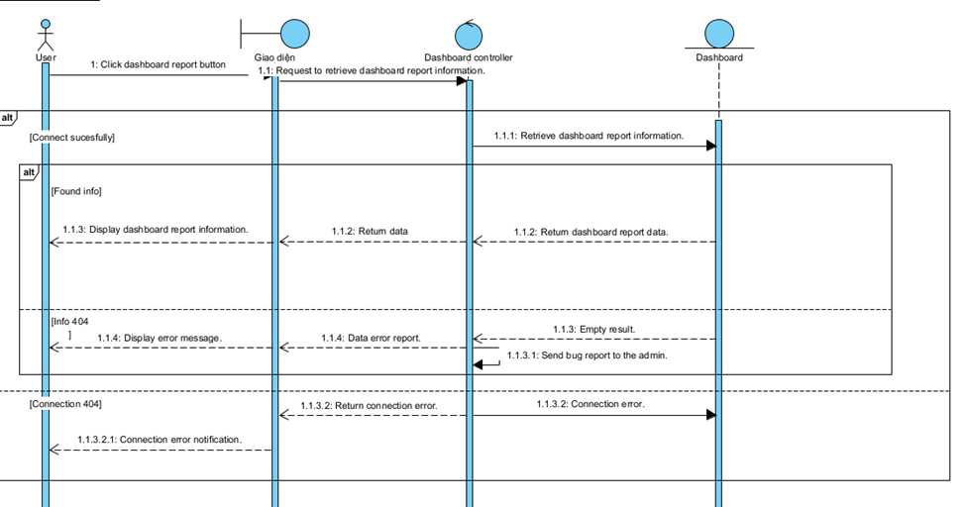

View System Alerts
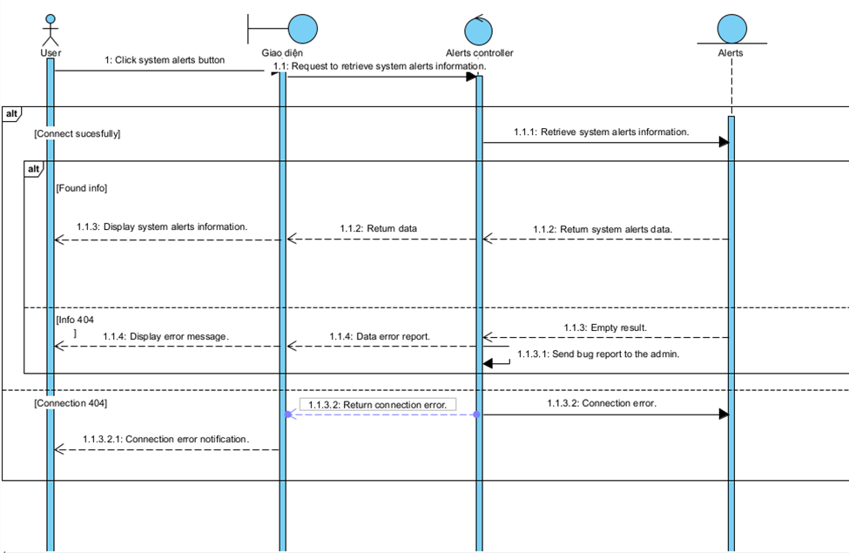

5.7 Class Diagram
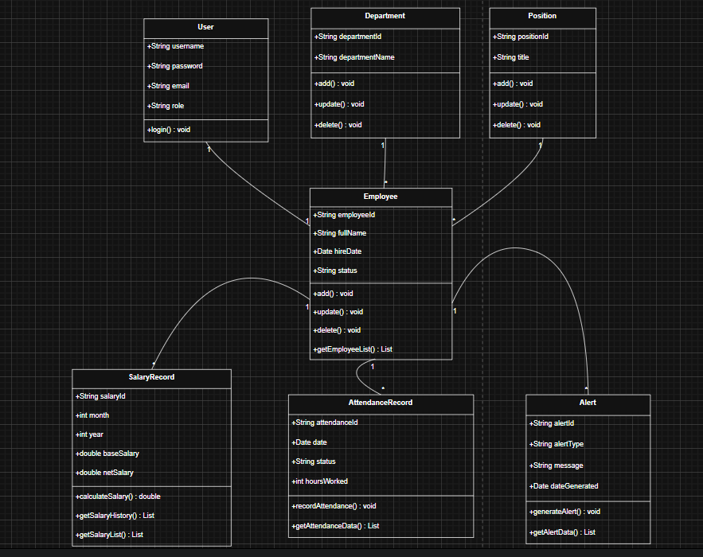

6. Other Requirements

6.1 Business Rules
ID | Business Rules
BR-01 | Unique Employee ID: Every newly added employee must have a unique EmployeeID that cannot be duplicated across the system.
BR-02 | Data Synchronization: Any changes to Employee, Department, or Position information in HUMAN_2025 (SQL Server) must be automatically and immediately synchronized to the PAYROLL system (MySQL).
BR-03 | Employee Deletion Constraint: Deletion of an employee is strictly prohibited if they have existing salary history in the PAYROLL system or dividend/contract data in the HUMAN_2025 system.
BR-04 | Role-Based Access Control (RBAC): Users are only permitted to access functions and data corresponding to their assigned Role (Admin, HR Manager, Payroll Manager, Employee).
BR-05 | Secure Authentication: Users must successfully log in through the centralized authentication system before accessing any Dashboard functionalities.
BR-06 | Department/Position Constraint: Departments or Positions cannot be deleted if there are employees currently assigned to them.
BR-07 | Salary Calculation: Net salary must be automatically calculated based on: Base Salary + Allowances/Bonuses - Deductions - Taxes (if applicable).
BR-08 | Reporting Cycle: Dashboard reports and analytical charts must be updated in real-time or according to the monthly payroll closing cycle.
BR-09 | Leave Warning Rule: The system must automatically calculate and issue an alert if an employee's leave exceeds the permitted number of days in a month/year.
BR-10 | Anniversary/Birthday Alerts: The system must automatically generate work anniversary or birthday notifications based on the HireDate and DOB fields.
BR-11 | Payroll Data Consistency: Salary data displayed on the Dashboard must perfectly match the original data in the backend database.
BR-12 | Session Security: User accounts will be temporarily locked after 3 consecutive failed login attempts, and active sessions will automatically terminate after a set period of inactivity.

6.2 System Constraints
- SC-01: The application must be developed as a web-based platform, capable of running on web servers like IIS or Tomcat.
- SC-02: The system must support deployment on both Windows Server and Linux Server environments.
- SC-03: The system must simultaneously connect to two existing databases: HUMAN_2025 (SQL Server) and PAYROLL (MySQL).
- SC-04 (Critical): No structural changes (schema modifications) are allowed to the existing HUMAN_2025 or PAYROLL databases.
- SC-05: The architecture must utilize RESTful APIs for seamless communication between the frontend (Dashboard UI) and the backend.
- SC-06: The system must ensure information security through a JSON Web Token (JWT) authentication mechanism.
- SC-07: The system must strictly enforce Role-Based Access Control (RBAC) across all API endpoints and UI components.
- SC-08: The system must guarantee secure data transmission by utilizing SSL/TLS encryption protocols (HTTPS).
- SC-09: The integrated system requires a stable Internet connection between the client, the API middleware, and the remote databases to ensure continuous operation.

Appendix

A: Glossary
Terminology | Explanation
Dashboard | A unified user interface that visually displays aggregated human resources, attendance, and payroll data.
Payroll | The system or automated process responsible for managing employee salaries, bonuses, deductions, and net pay calculations.
Leave Request | A formal request submitted by an employee to take time off from work (e.g., annual leave, sick leave).
Alert | An automated system notification triggered by specific business rules (e.g., work anniversaries, excessive absenteeism, salary discrepancies).
HUMAN_2025 | The existing legacy database (SQL Server) acting as the master source for HR data, including employee profiles, departments, and positions.
PAYROLL DB | The existing legacy database (MySQL) responsible for storing time-keeping (attendance) and salary records.
Authentication DB | A newly implemented, independent database dedicated solely to managing user accounts, passwords, and access permissions.
API (Application Programming Interface) | A set of rules and protocols that allows the frontend Dashboard to communicate seamlessly with the backend databases.
JWT (JSON Web Token) | A secure, compact token used to verify the identity and permissions of a user during their active session.
RBAC (Role-Based Access Control) | A security mechanism that restricts system access and API execution based on the specific role assigned to a user (e.g., Admin, HR Manager).
Data Synchronization | The automated process of ensuring that data remains consistent and up-to-date across both the HR and Payroll databases.
Middleware (Integration Layer) | The central backend layer (built with .NET or Flask) that orchestrates logic, connects to multiple databases, and serves data to the Dashboard .

– Requirement Traceability Matrix
BR ID | Business Requirement Description | FR ID | Functional Requirement Description | API Endpoint | Test Case ID | Status
BR-05  BR-12 | Secure Authentication & Session Security (Lockout/Timeout). | FR1 | The system shall allow users to log in securely through a separate authentication system. | POST /api/v1/auth/login | Chổ này sẽ để trống, sau khi viết tài liệu 9. System Testing-Report.docx thì update sau | Chổ này sẽ để trống, sau khi viết tài liệu 9. System Testing-Report.docx thì update sau
BR-04 | Role-Based Access Control (RBAC): Restrict access based on user roles. | FR2 | The system shall implement RBAC for API and UI access based on user roles. | GET /api/v1/usersPOST /api/v1/users
BR-01  BR-02  BR-03 | Unique ID, Data Synchronization, and Deletion Constraints for Employees. | FR3  FR4  FR5  FR6 | The system shall allow viewing, adding, updating, and deleting employees and prevent deletion if there are constraints. | GET /api/v1/employeesPOST /api/v1/employeesPUT /api/v1/employees/{id}DELETE /api/v1/employees/{id}
BR-02  BR-06 | Data Sync and Deletion Constraints for Departments. | FR7 | The system shall allow viewing, adding, updating, and deleting departments and sync to PAYROLL. | GET /api/v1/departmentsPOST /api/v1/departmentsPUT /api/v1/departments/{id}DELETE /api/v1/departments/{id}
BR-02  BR-06 | Data Sync and Deletion Constraints for Positions. | FR8 | The system shall allow viewing, adding, updating, and deleting positions and sync to PAYROLL. | GET /api/v1/positionsPOST /api/v1/positionsPUT /api/v1/positions/{id}DELETE /api/v1/positions/{id}
BR-07  BR-11 | Salary Calculation Rule and Payroll Data Consistency. | FR9  FR10 | The system shall allow viewing the salary list, salary history, and provide a payroll summary. | GET /api/v1/payrollGET /api/v1/payroll/{id}/history
BR-09 | Leave Warning Rule based on attendance. | FR11 | The system shall allow viewing attendance data and generating leave/absence analytics. | GET /api/v1/attendanceGET /api/v1/attendance/{id}
BR-08 | Reporting Cycle logic for Dashboard updates. | FR12FR13FR14FR15 | The system shall generate HR, payroll, attendance, and dividend reports. | GET /api/v1/reports/hrGET /api/v1/reports/payrollGET /api/v1/reports/attendanceGET /api/v1/reports/dividends
BR-10 | Anniversary, Birthday, and Salary Discrepancy Alerts. | FR16FR17FR18 | The system shall automatically generate work anniversary, excessive leave, and salary discrepancy alerts. | GET /api/v1/alerts

